**Memo**

To: Professor Pisano

From: Team 9

Team: 9

Date: 07/04/2022

Subject: Test Report

1. **Test Summary**

**1.1 List of Materials**

Hardware:

Raspberry Pi 4 B (with 32GB SanDisk SDHC Class 10 card)

Raspberry Pi fans

Wavefarm 10DOF IMU (MPU9255 + BMP280)

Sparkfun NEO-M9N u.FL GPS

Raspberry Pi 4 Camera 5MP OV5648 *2

QWIIC Connector and Cable for Raspberry Pi

15W Power Adapter (Pi4)

Mini HDMI to HDMI cable

Active GPS antenna

Software:

Python Script:

Basic User Interface, control all sensor

Data collection, from IMU to readable txt file

3D real-time model, from IMU to 3D cube

GPS receiver, from GPS to txt file

Recording video in h.264 format

Image Analysis to capture the change of Airspeed dial

XDR File:

The input file to the Xplane simulator.

Google Colab notebook:

Scripts to calculate the angle of an airspeed dial

**1.2 Equipment Setup**

Raspberry Pi4:

1. Enable i2c interface
2. Enable Serial port interface
3. Disabled Serial console
4. Run gui2.py

Hardware Diagram:

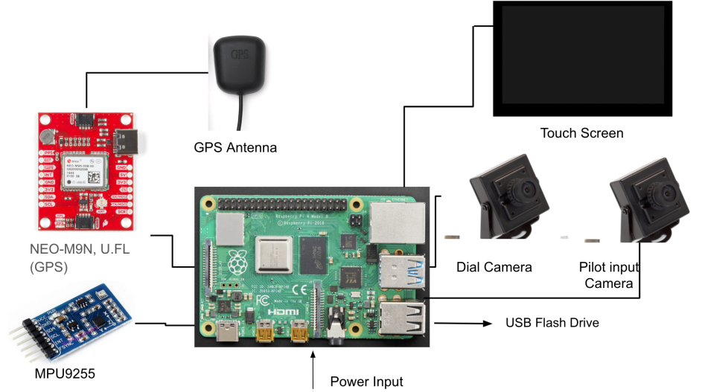

**1.3 Test Procedure**

Test 1: Extract data from sensors

1. Place the whole system outdoor
2. Get the result data which includes barometer, temperature, altitude, longitude, latitude, pitch, roll, yaw from output data file.
3. Check the real-time 3D model
4. Place the BerryGPS-IMU indoor
5. Get the same result data again
6. Compare the result data with the actual data which could be referenced on the Internet and make sure the system is working properly and precisely.

Test 2: Calculate angle of airspeed dial from image

1. Generate a toy image of an airspeed dial
2. Upload the image to the Google Colab notebook
3. Set the filename specified in the notebook to the name of the file
4. Run all the cells in the Synthesized Image section
5. See an output image of the dial and a calculated angle

Test 3: View .fdr file in X-Plane

1. Initiate X-Plane 11 on Windows/MacOS/Linux.
2. Use a generated .FDR file to run from modelled data and altering the highlighted factors above.
3. Load and initiate the available File .FDR, .SIT, .REP.
4. Verify data input against Flight Dashboard

**2.0 Measurements Taken**

**2.1 Measurements for Test 1: Extract data from sensors**

**IMU data**:

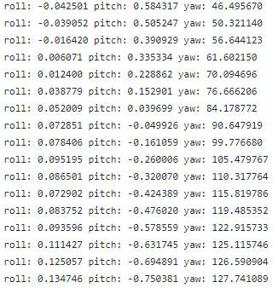

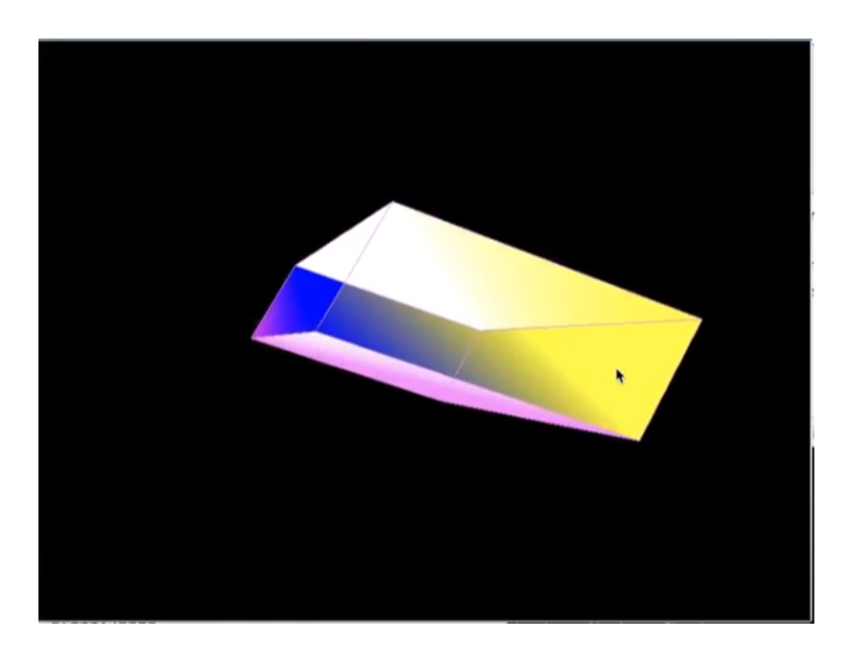

**Result**: Success. The value of roll/pitch/yaw changed accordingly when we place and change the maneuver of the system. Therefore, it will also perform well when we attach this to an aerobatic.

**Pressure/Altitude/Temperature data**:

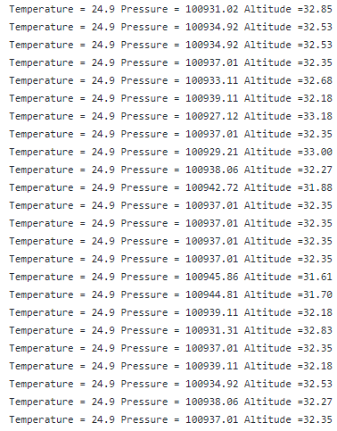

**Result**: Success. The temperature and the pressure is accurate and matched the average temperature and the pressure in Boston indoors. However, the Altitude data is calculated by an algorithm which uses Pressure, which means that the output data for altitude will be not so precise. Thus, we are not importing this part of data into the system and instead importing the data from the GPS module which can directly measure the altitude from where it is.

**GPS data**:

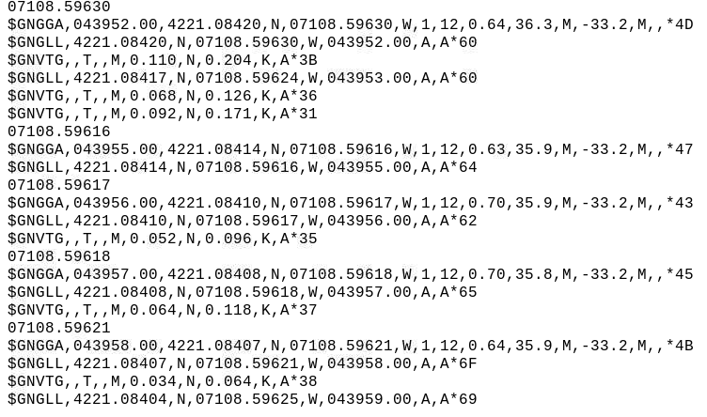

**Result**: Success. The GPS receiver capture the signal in a minture.

**Camera**: The camera records h.264 format video, and during the low light environment the camera automatically switches to IR mode. The demo video is uploaded to google drive.

**Result**: Success. It saves the video with a corresponding timestamp.

**2.2 Measurements for Test 2: Calculate angle of airspeed dial from image**

**Output image**:

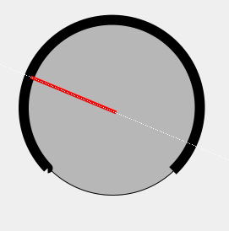

**Result**: Success. The code was able to detect the position and angle of the red dial, and overlay a line onto it.

**Calculated angle**:



**Result**: Success. The calculated angle matches visually with the angle of the dial in the image.

**2.3 Measurements for Test 3: View .fdr file in X-Plane**

**.FDR Sample 20 Seconds Linear Track**: Runs with a steady speed (250 Knt).

**Result**: Success.

**.SIT/.REP Sample Alteration & Data Recording**: Writes Data.txt while running.

**Result**: Success.

**.FDR Altered 20 seconds Linear Track**: Accelerates & decelerates based on provided data.

**Result**: Success.

**.FDR Altered 1 minute Right Embankment**: Runs, turns in one direction based on applied coordinates.

**Result**: Success.

**3.0 Conclusions**

All of the tests we performed were successful. Each test is representative of one stage in our project: data collection through sensors, data collection through image processing, and flight visualization using X-Plane. Together, these tests are a strong proof-of-concept for the design of our project.